TECHNICAL DATA SHEET
Molybdenum Grease
APPLICATION:
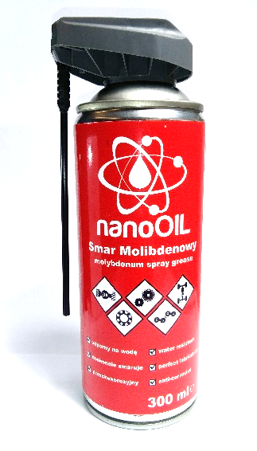
The product is intended for the lubrication of roller and slide bearings as well as device parts operating at high temperatures (up to 200°C), including those that are exposed to high loads. It is ideal for the regular conservation of guide bars, chains, hinges, etc. It is highly resistant to the effects of water and water vapour.
EFFECTS:
- reduces vibrations;
- works at high temperatures;
- displaces water, prevents corrosion;
- prevents elements from binding or seizing;
- reduces friction and eases elements that cooperate inside of mechanisms;
- limits the wear of parts that operate at high speeds;
- provides good resistance to alternating operational temperatures;
- protects against contaminants.
PHYSICAL AND CHEMICAL PROPERTIES:
physical state: aerosol
colour: black
odour: characteristic for paraffin products
melting/freezing point: unknown
initial boiling temperature: unknown
ignition temperature: > 0 ºC
flammability (solid, gas): extremely flammable
upper/lower explosive limit: unknown
density (20ºC): unknown
solubility: insoluble in water, soluble in organic solvents
explosive properties: forms explosive mixtures with air
oxidative properties: does not exhibit
dynamic viscosity: unknown

ECOLOGICAL INFORMATION:
The product is not classified as hazardous to the environment. No bioaccumulation is to be expected. The product contains volatile organic compounds (VOC), which easily evaporate from all surfaces. The product is volatile, it does not dissolve in water and is heavier than water. Do not allow for the product to be dumped into the sewage system or to contaminate surface water or soil. The product does not have an effect on global warming or the depletion of the ozone layer.
STABILITY AND REACTIVITY:
The product is reactive and hazardous polymerization does not occur. Vapours may form explosive mixtures with air.
HEALTH AND SAFETY:
Observe the general safety and hygiene rules. Avoid contact with eyes and skin. Remove immediately contaminated clothing. In the workplace, general and/or local ventilation should be provided to maintain the concentration of the harmful agent in the air below established limit values. When handling the product, do not eat, drink, smoke tobacco or consume medicine. Keep out of the reach of children. Do not pierce or burn, even after use.
STORAGE:
Store only in dry and well–ventilated place below 50ºC. Keep away from sources of fire and heat. Do not smoke and do not use open flames or sparking tools in the warehouse. Provide explosion–proof ventilation. Keep away from food, foodstuffs and animal feed. Protect from direct sunlight.
TRANSPORT:

The mixture poses no threat to the environment according to the criteria set out in the transport regulations. Packages shall not be thrown or subjected to impact. Containers/multi–packs should be placed on the vehicle or in the shipping box in such way to prevent them from falling down or dropping. Avoid heat sources.
NOTES:

